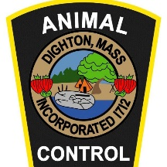 | DIGHTON POLICE DEPARTMENT  Office of Animal Control  1458 Somerset Ave.  Dighton, MA 02715  Phone: 508.669.6711  Adoption Schedule of Fees | 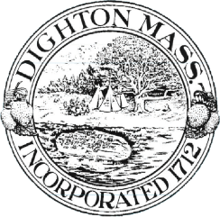
Dogs - $200
Cats - $150
Exotics - $50
Farm Animals - $150

